
TECHNICAL DATA BULLETIN

PAVER SAFETY BACKER (LU-SB-2424)
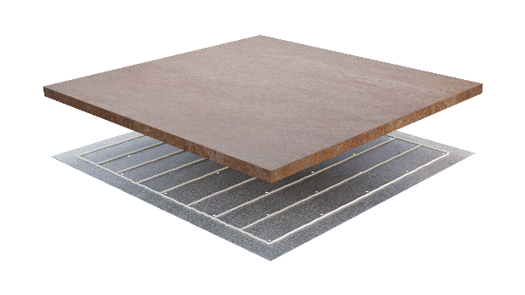
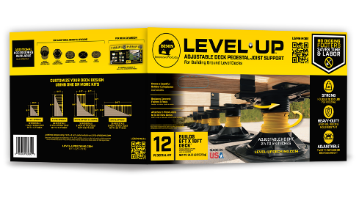
Bison® Level.Up™ Paver Safety Backers are required for use when installing outdoor 2CM porcelain pavers on the Bison Level.Up Adjustable Pedestals for Paver Support. The Paver Safety Backer enhances the impact resistance of the paver, while providing additional support. It also provides protection in the event of paver breakage. The Paver Safety Backer is adhered to the back of the paver using a one component polyurethane construction adhesive.
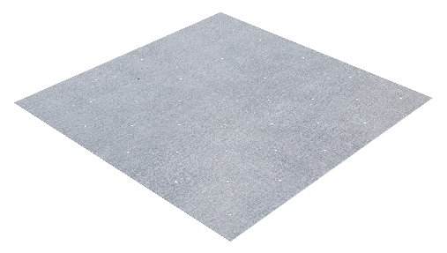

LEVEL.UP PAVER SAFETY BACKER SPECIFICATIONS:
- Measures 23.35 inches long x 23.35 inches wide x 0.02 inches thick (595 mm long x 595 mm wide x 0.6 mm thick).
- Weight: 3.05 lbs (1.38kg) each
- Compatible with square outdoor paver tiles measuring 593-601 mm long x 593-601 mm wide.
- Made of G90 galvanized steel which provides resistance to, but will not completely, prevent corrosion.
- Any cut edges must be sealed with primer or cold galvanizing spray to readminister the galvanizing layer.
- Level.Up Paver Safety Backers should NOT be installed fully submerged in any type of water. Accelerated corrosion can occur when Level.Up Paver Safety Backers are used in tidal areas or in direct contact with highly chlorinated or salt water which reduces the normal lifespan of the product.
- The Level.Up Paver Safety Backer does NOT provide wind uplift resistance.
- It will NOT prevent any surface material from cracking, chipping or breaking.
- It is up to the installer to independently verify that the surface material used (concrete, stone, porcelain, wood) provides the product strength, span rating, weight bearing capacity, material compatibility and suitability for the intended use.

HOW TO INSTALL PAVER SAFETY BACKERS:

WARNING! FOLLOW POWER TOOL, HAND TOOL & ADHESIVE MANUFACTURERS’ INSTRUCTIONS FOR SAFE USE AND HANDLING. WEAR APPROPRIATE PERSONAL PROTECTIVE EQUIPMENT (PPE) INCLUDING SAFETY GOGGLES, MASKS FOR RESPIRATORY PROTECTION AND GLOVES TO AVOID INJURY FROM THE SHARP EDGES. ENSURE THE WORK AREA IS WELL-VENTILATED AND HAS A WAY TO MANAGE WATER RUN-OFF FROM WET CUTTING OF PAVERS. AVOID WEARING LOOSE CLOTHING, JEWELRY AND TIE HAIR BACK TO PREVENT ACCIDENTS. ALWAYS WET CUT PAVERS TO MINIMIZE DUST. BE CAUTIOUS OF POTENTIAL KICKBACK WHEN CUTTING ESPECIALLY WITH LARGE OR HEAVY PAVERS.
- The Level.Up Paver Safety Backers are adhered to the back of the surface pavers using a polyurethane construction adhesive.
- The Paver Safety Backers MUST be adhered to the paver surface material before installation on the Level.Up Pedestal system.
- The Paver Safety Backers should be adhered to the pavers on the building site location.

RECOMMENDED ADHESIVE & COVERAGE:
IMPORTANT: Before applying the adhesive, thoroughly read and follow the adhesive manufacturer’s instructions for use and handling, safety and storage.

A one-component, moisture-curing polyurethane construction adhesive is recommended for adhering the Paver Safety Backer to the surface paver. It should provide strong adhesion to adhere dissimilar substrates.

Using a 1/8 inch diameter bead and applying in the configuration indicated below (Images 1a,1b, 1c), the following coverage should be achieved per adhesive size:
- One 310 mL cartridge adheres 6- 24 inch x 24 inch pavers & Paver Safety Backers
- One 600 mL sausage adheres 12 – 24 inch x 24 inch pavers & Paver Safety Backers

ADHERING A 2CM PAVER TO THE PAVER SAFETY BACKER PRIOR TO INSTALLATION:
IMPORTANT: For proper adhesion and performance, the adhesive must be applied EXACTLY as shown in Images 1a, 1b, 1c. During assembly, limit exposure to standing moisture, direct sunlight, and temperatures outside of 40°F to 100°F (5°C to 37°C). Wear appropriate work gloves to protect against sharp edges, and safety goggles when handling Safety Backers. Safety Backers should be adhered to the pavers on the build site.
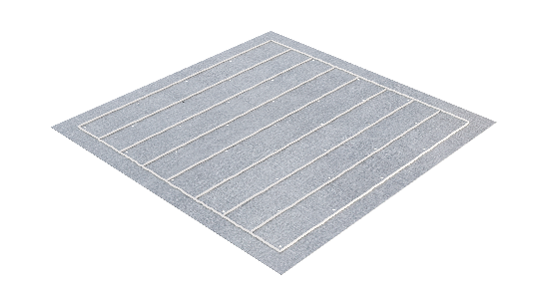
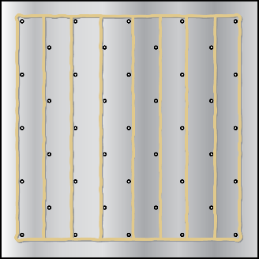
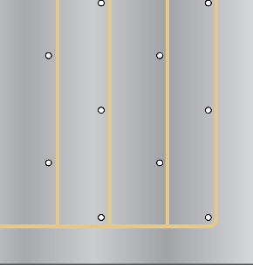
Images 1a,1b, 1c

- Set up four Level.Up Adjustable Pedestals (LU) with Spacer Tabs (LU-ST) or Fixed Height Pedestals (LU-FH50) to use as a base to stack the 2CM pavers and Paver Safety Backers while the adhesive cures.
- Place the first 2CM paver with the finish side face down over the four pedestals as shown in Image 2.
- Insert the adhesive cartridge or sausage into the appropriate caulk gun or sausage applicator. Cut the nozzle to a 1/8 inch diameter bead size. Break foil seal if necessary.
- Run a 1/8 inch diameter bead of adhesive, offset ¼ inch from the holes in the Safety Backer, as shown in the pattern in Images 1a,1b, 1c. To prevent moisture from entering between the paver tile and the Paver Safety Backer, a continuous perimeter bead of adhesive must be applied along the edge of the Paver Safety Backer.
- Place the adhesive side of the Paver Safety Backer squarely onto the paver, carefully aligning by hand to make sure that the Paver Safety Backer does not extend beyond any edge of the surface paver. See Image 3.
- Apply pressure to the Pave Safety Backer and wipe away any excess adhesive that may have seeped through the holes or beyond the edge of the Paver Safety Backer.
- Repeating Steps 4-6, gently stack the pavers SAFETY BACKER TO SAFETY BACKER IN PAIRS, rotating as shown in Image 4. STACK NO MORE THAN TEN (10X) PAVERS HIGH. Allow them to set for the adhesive manufacturer’s recommended cure time (approximately 2 to 4 hours), before handling and installing on the pedestals.
Pro Tip: Pull pavers from different boxes and/or pallets to achieve an even color distribution.

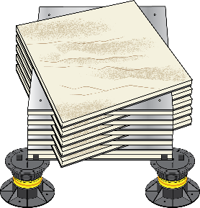
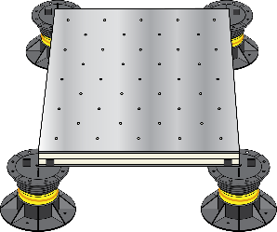
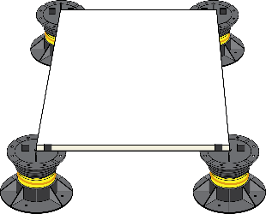

Image 2 Image 3 Image 4

CUTTING 2CM PAVERS & SAFETY BACKERS:
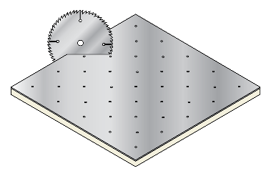
- The Level.Up Paver Safety Backers and 2CM pavers may be cut pre- or post-assembly. It is important to select the appropriate tools and blades before cutting the Paver Safety Backer and paver surface materials.
- For extended lifespan of the cutting blade, consider using a diamond etched porcelain/ceramic blade for cutting 2CM porcelain pavers. When cutting the Paver Safety Backers, use either a jigsaw or steel cutting abrasive wheel. If cutting the Paver Safety Backer before adhering to the paver, a sheet metal shear may be used.
- If cuts are to be radial or curved, score the 2CM paver along the desired cut line, and then cut through with a smaller diameter circular blade. Scoring the paver (by itself or adhered to the Paver Safety Backer) before cutting helps to prevent fracturing. Consider creating incremental relief cuts up to the score line if the curve causes too much stress for the blade.

IF CUTTING THE PAVER BEFORE ADHERING TO THE PAVER SAFETY BACKER:
  - Measure and cut the paver along the desired cut line.
  - Place the cut paver atop the Paver Safety Backer, aligning finish paver sides with the finish sides of the Paver Safety Backer. Trace the cut line onto the backer and then proceed to cut the Paver Safety Backer by itself.
  - Once cut to the desired shape size, use a metal file or angle grinder to smooth any sharp edges or burrs created along the cut line. CAUTION: DO NOT RUN YOUR FINGERS ALONG THE CUT LINE OR ANY VISIBLE BURRS.
  - Adhere the cut Safety Backer to the cut paver with polyurethane construction adhesive following the instructions outlined above. It is necessary to apply the bead of adhesive in the same pattern as indicated Images 1a, 1b, 1c, along any cut edges, to maintain a continuous perimeter seal between the Paver Safety Backer and the paver. Remove any surface debris, and if using a wet cutting technique, dry materials prior to apply the adhesive.
  - Re-galvanize the cut edges of the Paver Safety Backer by painting the cut edges of the Paver Safety Backer with primer or cold galvanizing spray to re-administer galvanizing layer removed by cutting (exposure to heat, grinding, and/or water) to prevent rust damage.

IF CUTTING THE PAVER AFTER ADHERING TO THE PAVER SAFETY BACKER:
  - Measure and cut the Paver Safety Backer and paver along the desired cut line.
  - Once cut to the desired shape and size, use a metal file or angle grinder to smooth any sharp edges or burrs created along the cut line. CAUTION: DO NOT RUN YOUR FINGERS ALONG THE CUT LINE OR ANY VISIBLE BURRS.
  - Use a small amount of cleaner to remove any adhesive from the paver or saw blade, if needed. Wash with a clean rag and mild soap to remove any slippery residue.
  - It is necessary to apply a bead of adhesive along any cut edges, to maintain a continuous perimeter seal between the Paver Safety Backer and the paver. Remove any surface debris, and if using a wet cutting technique, dry materials prior to apply the adhesive.
  - Re-galvanize the cut edges of the Paver Safety Backer by painting the cut edges of the Paver Safety Backer with primer or cold galvanizing spray to re-administer galvanizing layer removed by cutting (exposure to heat, grinding, and/or water) to prevent rust damage.
IMPORTANT – BEFORE BUILDING:
- Before beginning any work, READ ALL INSTRUCTIONS, TECHNICAL DATA SHEETS AND MATERIALS WITH THIS PRODUCT.
- Installation MUST be completed in accordance with the Bison Level. Up Installation Guide instructions and Technical Data Sheet. Follow these instructions and utilize best practices for actual installation. These are available on LEVEL-UPDECKING.COM.
- Bison Level.Up Pedestal Paver Supports, components and accessories are for the SOLE PURPOSE of installing ground-level, elevated paver patio decks only. NOT INTENDED FOR ROOFTOP INSTALLATIONS.
- The Level.Up Pedestal Systems are NOT to be attached to a home, structure or foundation.
- Level.Up Adjustable Pedestals are NOT for use in high wind zone areas. Before beginning any work, determine whether the paver patio deck will be installed in a high wind zone. High wind zone maps are available on the International Code Council website at iccsafe.org.
- ALWAYS check all local zoning laws, municipalities, codes and Homeowners Association (HOA) regulations before beginning any work.
- Product is designed to meet or exceed Standard 2024 International Residential Code (IRC) building practices.
SAFETY FIRST
- Verify that the correct materials, tools, equipment and personal protective equipment (PPE) are used.
- ALWAYS wear appropriate personal protective equipment (PPE). This includes work gloves, safety glasses and respiratory masks when required. Failure to do so could result in serious injury and/or death.
- Failure to install the paver patio deck consistent with the provided instructions and/or ignoring any hazard disclaimers stated in this document could cause total patio deck failure and/or collapse, which could result in property damage, serious injury, and/or death.
- WARNING! FOLLOW POWER TOOL, HAND TOOL & ADHESIVE MANUFACTURERS’ INSTRUCTIONS FOR SAFE USE AND HANDLING. WEAR APPROPRIATE PERSONAL PROTECTIVE EQUIPMENT (PPE) INCLUDING SAFETY GOGGLES, MASKS FOR RESPIRATORY PROTECTION AND GLOVES TO AVOID INJURY FROM THE SHARP EDGES. ENSURE THE WORK AREA IS WELL-VENTILATED AND HAS A WAY TO MANAGE WATER RUN-OFF FROM WET CUTTING OF PAVERS. AVOID WEARING LOOSE CLOTHING, JEWELRY AND TIE HAIR BACK TO PREVENT ACCIDENTS. ALWAYS WET CUT PAVERS TO MINIMIZE DUST. BE CAUTIOUS OF POTENTIAL KICKBACK WHEN CUTTING ESPECIALLY WITH LARGE OR HEAVY PAVERS.
- ALWAYS contact local utility companies before digging or removing soil.
- Do NOT attempt to lift heavy objects alone. Use lifting aids or ask for help when moving heavy objects. Use proper techniques to avoid muscle strain or back injuries.
- Be aware of surroundings and when working around the paver patio deck during construction to avoid tripping.
- Ensure Level.Up pedestals and paver patio decks are stable throughout the construction process. Adjust paver pedestal components for slope and height to maintain level and stability. Add proper accessories when additional slope or height is required per instructions stated in this document.
- Be careful not to fall off the edge of the elevated paver patio deck. Railings and/or guards are not required for patio deck heights below 20 inches, unless specifically required by local ordinance. However, a fall from this height could still result in serious injury and/or death. Always check with local municipalities if railings and/or guards are required for desired patio deck location.
- Stair or step may be necessary pending the desired height of the paver patio deck. Be sure to verify if a step or “step down” fixture is required with the design. Always check with local municipalities for verification of final installation.
HAZARDS & DISCLAIMERS
- All drawings provided are NOT to scale.
- Bison Innovative Products & DAP Global Inc. are NOT responsible for improper installation.
- Bison Innovative Products & DAP Global Inc. are NOT responsible for damages caused by improper installation or misuse.
- Make sure the building site is properly prepared before beginning construction. See Section 8 of the Installation Guide for details.
- The perimeter of the elevated paver patio deck MUST be contained on all sides by a perimeter containment wall to prevent lateral movement of the pedestals and pavers. See Section 8 of the installation guide for details.
- The Bison Level.Up Adjustable Pedestal, including all components and accessories, is NOT to exceed 12 inches in height. This does NOT include the additional height of the surface paver material.
- Do NOT overload the Level.Up Adjustable Paver Pedestals with excessive weight. Each Level.Up pedestal is rated to 750 lbs weight bearing capacity. Heavy features or fixtures exceeding 350 lbs (examples include but are not limited to hot tubs, water fixtures, concrete statues) will require additional pedestal support.
- Do NOT attach pergolas to the Level.Up paver patio deck.
- Do NOT place fire features, stoves or chimeneas directly on top of the paver patio deck.
- Do NOT add any feature or fixture that creates heavy vibration that can be transmitted to the foundation and cause pedestal shifting or soil erosion. Examples include but are not limited to air conditioning units, HVAC condensers, fountains, or home generators.
- All motor vehicles are strictly PROHIBITED from being stored or driven on Bison Level.Up Pedestal paver patio decks. Examples include, but are not limited to, cars, motorcycles, 4-wheelers, ATV’s, riding lawn mowers. Bison Level.Up Pedestal paver patio decks are designed for pedestrian traffic only.

Manufacturer: H&H Metals, 12520 Grant Drive, #100 Thornton, CO 80241-2511
Distribution of Product: DAP Global Inc., 2400 Boston Street, Baltimore, MD 21224
Usage Information: Call 877-327-7378 or visit level-updecking.com
Fax Information: 410-558-1068
Order Information: Call 877-327-7378 or email: orders@dap.com

