
TECHNICAL DATA BULLETIN
LEVEL.UP ADJUSTABLE PEDESTALS FOR PAVER SUPPORT
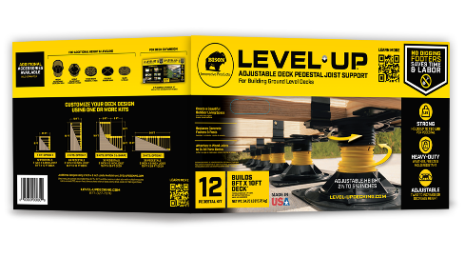
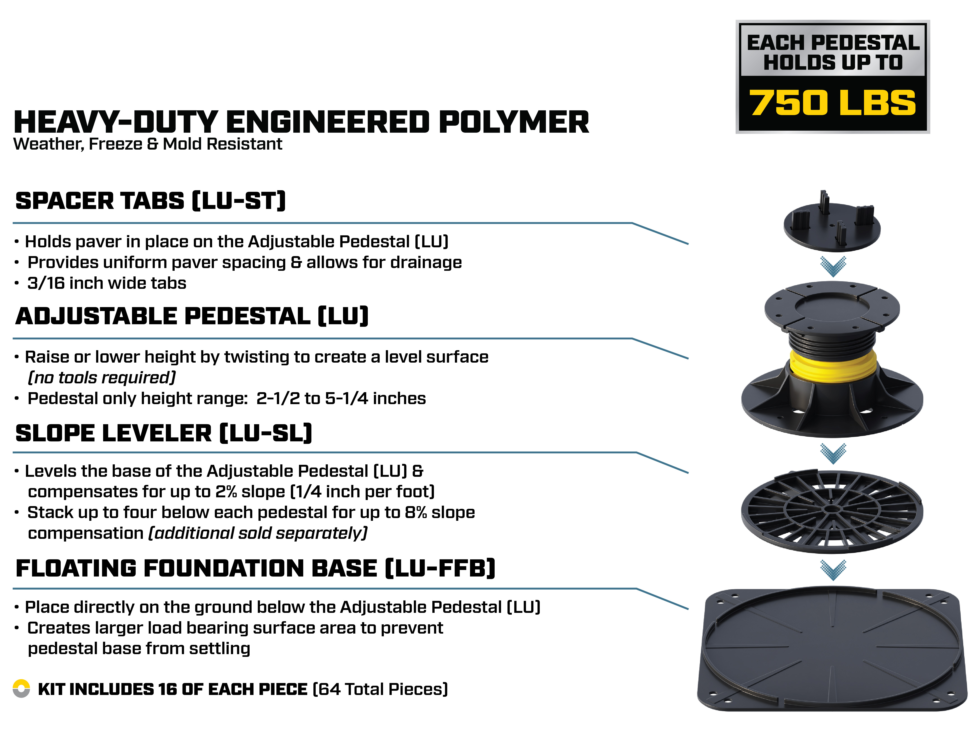Bison® Level.Up™ Adjustable Pedestals for Outdoor Paver Support provide a revolutionary way to build elevated, on-grade patio paver decks. The Adjustable Pedestals simplify ground prep by eliminating the need to level the existing ground surface. They reduce installation time, saving time, labor and cost. The Adjustable Pedestals elevate and support 2CM porcelain pavers, concrete pavers and wood tiles, while providing uniform spacing and drainage. They can be installed over existing hard surfaces such as concrete slabs and pavers or compact non-eroding soil or gravel. The telescoping pedestals easily twist by hand to adjust for height – no tools needed. Ground slope can be corrected up to 8% using Slope Levelers. Use one or more kits for a customizable design. The heavy-duty, engineered polymer pedestals are weather, freeze and mold resistant. Additional accessories are available and sold separately to provide additional height, leveling or support.
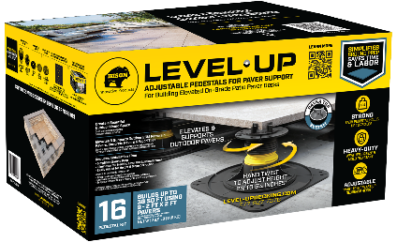

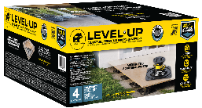

PAVER PATIO DECK SPECIFICATIONS:
- Bison Level.Up Adjustable Pedestal Paver Supports, components and accessories are intended for the sole purpose of installing on-grade patio paver decks. NOT INTENDED FOR ROOFTOP INSTALLATIONS.
- The maximum height of the pedestal system including any accessories is 12 inches. This does not include the paver surface material.
- The perimeter of the elevated patio paver deck MUST be contained on all sides to prevent lateral movement of the pedestals and pavers. The perimeter containment wall can be installed before or after the installation of the pedestals and pavers. The perimeter containment wall can consist of the following or combination of the following: sides of a house or structure, retaining wall consisting of masonry, railroad ties and metal stakes, etc. The perimeter containment wall MUST be flush with the top of the paver surface material or higher. Please refer to the Level.Up Installation Guide for additional details regarding the perimeter containment wall.
- Do NOT attach Level.Up Paver Pedestals to a structure, foundation or ground surface.
- Pedestals MUST be installed over stable compacted soil or gravel, concrete or other hard surfaces. The compacted soil or gravel must be free from soil erosion before starting any work.
- Bison Level.Up Paver Pedestal Systems MUST be installed on a stable grade surface that is well-draining. If the area is prone to flooding, standing water, or constantly wet, the area will require ground drainage to ensure that the area will not be susceptible to soil erosion over time. Ground drainage can be introduced through drainage solutions, gravel build-up, rerouting water at the source, etc. Consult a professional when required. Always direct water away from the home or structures on the property.
- Sod, vegetation, mulch and debris must be removed, and the ground must be well-compacted when installing over soil. Make sure the installation area is NOT prone to erosion. Be careful not to damage any sprinkler lines or other equipment. Call your local utility providers before digging or removing any soil.
- Grade the slope away from the house or structure. Maximum ground slope at any given point is 8%.
- Build the patio paver deck around existing drainage. Drainage can run underneath or on top of the patio deck.
- All surface materials (concrete pavers, 2CM porcelain pavers, wood tiles), containment wall materials and any other materials utilized should be rated for both exterior and ground contact uses. It is up to the installer to independently verify that the surface material used (concrete, stone, porcelain, and/or ceramic pavers, wood) provide the product strength, span rating, weight bearing capacity, material compatibility and sustainability for the intended use.

PEDESTAL HEIGHT OPTIONS:
- The height of the Level.Up Deck Pedestal (LU) can be increased or decreased by twisting and/or removing the inner yellow coupler. Twist the base of the Pedestal clockwise to raise height and counterclockwise to lower height. The lowest height is 2 inches, and highest height is 4-3/4 inches. When the Level.Up Pedestal Paver Support System is fully assembled with the Spacer Tab, Slope Leveler and Floating Foundation base, the lowest height is 2-3/4-inches (when internal coupler is removed) and its highest height is 5-1/2 inches.
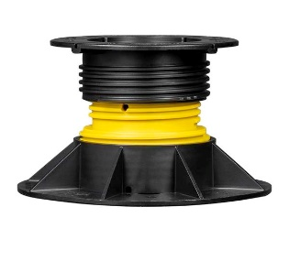
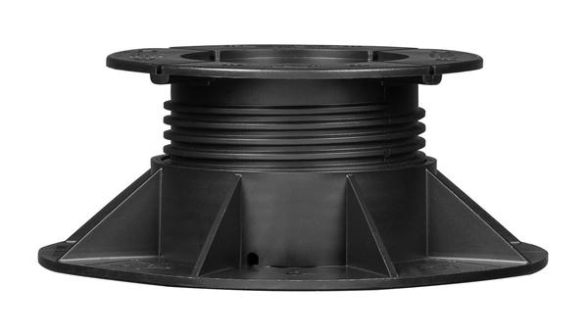
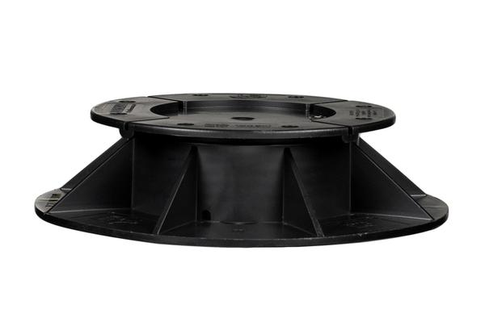
Pedestal at Full Height Expansion WITH Inner Yellow Coupler: 4-3/4 Inches
Pedestal at Lowest Height WITH Inner Yellow Coupler: 2-1/2 Inches
Pedestal at Lowest Height REMOVING Inner Yellow Coupler: 2 Inches

- Once fully assembled, the total pedestal height, including accessories, cannot exceed 12 inches. This height does not include the added height of the surface paver materials. Should additional height be required due to slope of terrain, installation may require the use of Height Adjustment Couplers or additional Slope Levelers.
- Do not over-extend the Level.Up Paver Pedestals (LU). Adjustable Paver Pedestals (LU) and their couplers have raised engagement bumps that will be felt and heard when unscrewed to the maximum height. Do not force or unscrew further when these engagements are detected. Pedestals are tested to a maximum height of 12 inches. Going beyond this height or beyond the engagement bumps on any individual connection may compromise the weight-bearing capacity and structural integrity of the Pedestal causing failure.
- DO NOT overload the Level.Up Pedestals. Each Level.Up Pedestal is rated to a 750 lbs. weight bearing capacity. Heavy features or fixtures exceeding 350 lbs. (examples include but are not limited to hot tubs, water fixtures, concrete statues) may require additional substructure materials and pedestal support. Call 877-327-7378 for additional guidance, should this need arise.

IMPORTANT – BEFORE BUILDING:
- Before beginning any work, READ ALL INSTRUCTIONS, TECHNICAL DATA SHEETS AND MATERIALS WITH THIS PRODUCT.
- Installation MUST be completed in accordance with the Bison Level. Up Installation Guide instructions and Technical Data Sheet. Follow these instructions and utilize best practices for actual installation. These are available on LEVEL-UPDECKING.COM.
- Bison Level.Up Pedestal Paver Supports, components and accessories are for the SOLE PURPOSE of installing ground-level, elevated paver patio decks only. NOT INTENDED FOR ROOFTOP INSTALLATIONS.
- The Level.Up Pedestal Systems are NOT to be attached to a home, structure or foundation.
- Level.Up Adjustable Pedestals are NOT for use in high wind zone areas. Before beginning any work, determine whether the paver patio deck will be installed in a high wind zone. High wind zone maps are available on the International Code Council website at iccsafe.org.
- ALWAYS check all local zoning laws, municipalities, codes and Homeowners Association (HOA) regulations before beginning any work.
- Product is designed to meet or exceed Standard 2024 International Residential Code (IRC) building practices.
- ALWAYS inspect all products before using or starting to install materials to the Level.Up Paver Pedestal System. All Bison Level.Up Paver Pedestal System components and accessories should be free from damage and in proper working condition.
- Do NOT substitute other manufacturers pedestals, accessories or parts with the Bison Level.Up Pedestal System.
MAINTENANCE:
- Routine maintenance of the paver patio deck and Level.Up Paver Pedestal System is required to enhance the beauty, reduce major repairs and prolong the life of the paver patio deck.
- Periodically check for erosion, sink, and pedestal integrity. Adjust as needed.
- Check for pavers that rock. If you notice pavers rocking back and forth while walking on the patio deck, simply lift the paver up and shim one or more corners until the paver is level on all four corners. Level.Up Shims can be used for this purpose.
- Depending on ground substrate materials, some settling may occur. Remove the paver and adjust the pedestal until a level height is achieved. This may need to be done to more than one pedestal to level out a specific area.
- Clean any drains below or near the paver deck on a regular basis. Water should completely drain off the patio within 48 hours after a rainfall under ambient drying conditions. Standing or pooling water can be detrimental.
- Periodically check the Spacer Tabs between the pavers. Relace any broken Spacer Tabs immediately. Loss of Spacer Tabs could create unsafe patio movement.
- There should be no more than a 3/16 inch (4.5 mm) gap between pavers at any perimeter edge. The patio deck should not exhibit any lateral movement which could create an unsafe condition.
- Particular attention should be made to assure that all pedestrian entry or access points to the patio deck are level and that the patio deck surface pavers are not randomly raised or uneven creating a tripping or safety hazard.
- To avoid further damage or injury, immediately replace any cracked, chipped or broken surface pavers and the accompanying Level.Up Paver Safety Backer (if used) with new pavers and Paver Safety Backers (if used). The Paver Safey Backer is not intended to be a reusable product and must be replaced with a new surface paver.
- After construction is completed, check both the paver patio deck and perimeter containment wall periodically throughout the year to ensure that there has been no movement and that the perimeter containment wall is stable and structurally sound. Make the necessary repairs or replacement if needed.
- When cleaning the patio deck, chlorine and standard soaps are safe to use on and around the Pedestal System. Chemicals, such as gasoline or turpentine, should not be stored or used in the vicinity of the Pedestal System. If spilled, such products could cause damage to the pedestals and any accessories utilized with them. Call 877-327-7378 for any additional questions or concerns.
- Clean and maintain the paver/surface material following the paver/surface material manufacturer’s instructions.

SAFETY FIRST
- Verify that the correct materials, tools, equipment and personal protective equipment (PPE) are used.
- ALWAYS wear appropriate personal protective equipment (PPE). This includes work gloves, safety glasses and respiratory masks when required. Failure to do so could result in serious injury and/or death.
- Failure to install the paver patio deck consistent with the provided instructions and/or ignoring any hazard disclaimers stated in this document could cause total patio deck failure and/or collapse, which could result in property damage, serious injury, and/or death.
- WARNING! FOLLOW POWER TOOL, HAND TOOL & ADHESIVE MANUFACTURERS’ INSTRUCTIONS FOR SAFE USE AND HANDLING. WEAR APPROPRIATE PERSONAL PROTECTIVE EQUIPMENT (PPE) INCLUDING SAFETY GOGGLES, MASKS FOR RESPIRATORY PROTECTION AND GLOVES TO AVOID INJURY FROM THE SHARP EDGES. ENSURE THE WORK AREA IS WELL-VENTILATED AND HAS A WAY TO MANAGE WATER RUN-OFF FROM WET CUTTING OF PAVERS. AVOID WEARING LOOSE CLOTHING, JEWELRY AND TIE HAIR BACK TO PREVENT ACCIDENTS. ALWAYS WET CUT PAVERS TO MINIMIZE DUST. BE CAUTIOUS OF POTENTIAL KICKBACK WHEN CUTTING ESPECIALLY WITH LARGE OR HEAVY PAVERS.
- ALWAYS contact local utility companies before digging or removing soil.
- Do NOT attempt to lift heavy objects alone. Use lifting aids or ask for help when moving heavy objects. Use proper techniques to avoid muscle strain or back injuries.
- Be aware of surroundings and when working around the paver patio deck during construction to avoid tripping.
- Ensure Level.Up pedestals and paver patio decks are stable throughout the construction process. Adjust paver pedestal components for slope and height to maintain level and stability. Add proper accessories when additional slope or height is required per instructions stated in this document.
- Be careful not to fall off the edge of the elevated paver patio deck. Railings and/or guards are not required for patio deck heights below 20 inches, unless specifically required by local ordinance. However, a fall from this height could still result in serious injury and/or death. Always check with local municipalities if railings and/or guards are required for desired patio deck location.
- Stair or step may be necessary pending the desired height of the paver patio deck. Be sure to verify if a step or “step down” fixture is required with the design. Always check with local municipalities for verification of final installation.
HAZARDS & DISCLAIMERS
- Bison Innovative Products & DAP Global Inc. are NOT responsible for improper installation.
- Bison Innovative Products & DAP Global Inc. are NOT responsible for damages caused by improper installation or misuse.
- Make sure the building site is properly prepared before beginning construction. See Section 8 of the Installation Guide for details.
- The perimeter of the elevated paver patio deck MUST be contained on all sides by a perimeter containment wall to prevent lateral movement of the pedestals and pavers. See Section 8 of the installation guide for details.
- The Bison Level.Up Adjustable Pedestal, including all components and accessories, is NOT to exceed 12 inches in height. This does NOT include the additional height of the surface paver material.
- It is up to the installer to independently verify that the surface material used (concrete, stone, wood) provides the product strength, span rating, weight bearing capacity, proper PSF for standing surfaces, material compatibility and suitability for the intended use.
- Do NOT overload the Level.Up Adjustable Paver Pedestals with excessive weight. Each Level.Up pedestal is rated to 750 lbs. weight bearing capacity. Heavy features or fixtures exceeding 350 lbs. (examples include but are not limited to hot tubs, water fixtures, concrete statues) will require additional pedestal support.
- Do NOT attach pergolas to the Level.Up paver patio deck.
- Do NOT place fire features, stoves or chimeneas directly on top of the paver patio deck.
- Do NOT add any feature or fixture that creates heavy vibration that can be transmitted to the foundation and cause pedestal shifting or soil erosion. Examples include but are not limited to air conditioning units, HVAC condensers, fountains, or home generators.
- All motor vehicles are strictly PROHIBITED from being stored or driven on Bison Level.Up Pedestal paver patio decks. Examples include, but are not limited to, cars, motorcycles, 4-wheelers, ATV’s, riding lawn mowers. Bison Level.Up Pedestal paver patio decks are designed for pedestrian traffic only.

Manufacturer: Bison Innovative Products; 701 Osage Street, Unit 120, Denver, CO 80204
Distribution of Product: DAP Global Inc., 2400 Boston Street, Suite 200, Baltimore, MD 21224
Usage Information: Call 877-327-7378 or visit level-updecking.com
Order Information: Call 877-327-7378 or email: orders@dap.com. Fax: 410-558-1068

